**Smart Waste Management System For Metropolitan Cities**

**IBM-Project-26207-1660020965**

**NALAIYA THIRAN PROJECT BASED LEARNING ON PROFESSIONAL READLINESS FOR INNOVATION, EMPLOYNMENT AND ENTERPRENEURSHIP**

**A PROJECT REPORT**

**BY**

Hari Vignesh K (310619205033)

Ajay R (310619205006)

Harish Kumar G (310619205036)

Aakash S K (310619205001)

Chaturvedi V (310619205501**)**

**BACHELOR OF TECHNOLOGY IN INFORMATION TECHNOLOGY**

**EASWARI ENGINEERING COLLEGE, Chennai 600089**

**INDEX**

**1. INTRODUCTION**

* 1. Project Overview
  2. Purpose

1. **LITERATURE SURVEY**
   1. Existing problem
   2. References
   3. Problem Statement Definition
2. **IDEATION & PROPOSED SOLUTION**
   1. Empathy Map Canvas
   2. Ideation & Brainstorming
   3. Proposed Solution
   4. Problem Solution fit
3. **REQUIREMENT ANALYSIS**
   1. Functional requirement
   2. Non-Functional requirements
4. **PROJECT DESIGN**
   1. Data Flow Diagrams
   2. Solution & Technical Architecture
   3. User Stories

**6.PROJECT PLANNING & SCHEDULING**

6.1Sprint Planning & Estimation

6.2 Sprint Delivery Schedule

6.3 Reports from JIRA

**7.CODING & SOLUTION (Explain the features added in the project along with code)**

7.1Feature 1

7.2 Feature 2

7.3 Database Schema (if Applicable)

**8.TESTING**

8.1 Test Cases

8.2 User Acceptance Testing

**9.RESULTS**

9.1 Performance Metrics

**10.ADVANTAGES & DISADVANTAGES**

**11.CONCLUSION**

**12.FUTURE SCOPE**

**13.APPENDIX**

# 1.INTRODUCTION

## 1.1 Project Overview:

With the increasing population and industrialization of nations throughout the globe, waste has become a great concern for all of us. Over years, researchers figured that only waste management is not enough for its proper treatment and disposal techniques to preserve our environment and keeping it clean in this era of globalization. With the help of technology researchers have, introduced IoT based Smart Waste Management solutions and initiatives that ensures reduced amount of time and energy required to provide waste management services and reduce the amount of waste generated. Unfortunately, developing countries are not being able to implement those existing solutions due to many factors like socio-economic environment. Therefore, in this research we have concentrated our thought on developing a smart IoT based waste management system for developing countries like INDIA that will ensure proper disposal, collection, transportation and recycling of household waste with the minimum amount of resources being available

## 1.2 Purpose:

We amalgamate technology along with waste management in order to effectively create a safe and a hygienic environment. Smart waste management is about using technology and data to create a more efficient waste industry. Based on IoT (Internet of Things) technology, smart waste management aims to optimize resource allocation, reduce running costs, and increase the sustainability of waste services. This makes it possible to plan more efficient routes for the trash collectors who empty the bins, but also lowers the chance of any bin being full for over a week. A good level of coordination exists between the garbage collectors and the information supplied via technology. This makes them well aware of the existing garbage level and instigate them whenever the bins reach the threshold level.

They are sent with alert messages so that they can collect the garbage on time without littering the surrounding area. The fill patterns of specific containers can be identified by historical data and managed accordingly in the long term. In addition to hardware solutions, mobile applications are used to overcome the challenges in the regular waste management system, such as keeping track of the drivers while they are operating on the field. Thus, smart waste management provides us with the most optimal way of managing the waste in an efficient manner using technology

# 2. LITERATURE SURVEY:

# 2.1 Existing problem:

Waste management has become an alarming challenge in local towns and cities across the world. Often the local area bins are overflowing and the municipalities are not aware of it. This affects the residents of that particular area in numerous ways starting from bad odour to unhygienic and unsafe surroundings. Poor waste management - ranging from non-existing collection systems to ineffective disposal -causes air pollution, water and soil contamination. Open and unsanitary areas contribute to contamination of drinking water and can cause infection and transmit diseases. Toxic components such as Persistent Organic Pollutants (POPs) pose particularly significant risks to human health and the environment as they accumulate through the food chain. Animals eating contaminated plants have higher doses of contaminants than if they were directly exposed. Precipitation or surface water seeping through waste will absorb hazardous components from landfills, agricultural areas, feedlots, etc. and carry them into surface and groundwater. Contaminated groundwater also poses a great health risk, as it is often used for drinking, bathing and recreation, as well as in agricultural and industrial activities. Landfills and waste transfer stations can attract various pests (insects, rodents, gulls, etc.) that look for food from waste. These pests can spread diseases through viruses and bacteria (i.e., salmonella and e-coli), which are a risk to human health.

## 2.2 References:

**PAPER 1:**

**TITLE:** Smart waste management using IOT

**Author Name:** Gopal Krishna Shyam,Venkatachalam

**Publication Year:** 2017

**DESCRIPTION:**

In the current situation, we frequently observe that the trash cans or dust cans that

are located in public spaces in cities are overflowing due to an increase in the amount of waste produced each day. We are planning to construct “IoT Based Waste Management for Smart Cities” to prevent this from happening because it makes living conditions for people unsanitary and causes unpleasant odours in the surrounding area. There are numerous trash cans scattered throughout the city or on the campus that are part of the proposed system. Each trash can is equipped with a low-cost embedded device that tracks the level of the trash cans and an individual ID that will enable it to be tracked and identified.

## PAPER 2:

**TITLE:** smart solid waste management

**AUTHOR NAME:** mohammned abd alfi

## PUBLICATION YEAR: 2016

## DESCRIPTION:

Each bin in the Cloud SWAM system that Mohammad Aazame suggested has sensors that can detect the amount of waste inside. There are separate bins for organic, plastic/paper/bottle/glass, and metal waste. This way, each form of waste is already divided, and it is known how much and what kind of waste is collected thanks to the status. Different entities and stakeholders may benefit from the accessibility of cloud-stored data in different ways. Analysis and planning can begin as soon as garbage is collected and continue through recycling and import/export-related activities. Timely garbage collection is provided via the Cloud SWAM system. A timely and effective method of waste collection improves health, hygiene, and disposal.

## PAPER 3:

**TITLE:** Raspberry pi smart waste management system using iot

**AUTHOR NAME:**shaik vaseem akram,rajesh singh

**PUBLICATION YEAR:** 2019

**DESCRIPTION:**

In this paper, a technique for cleaning up our surroundings and environment is

described. The Indian government just began work on a smart city initiative, and in order for these towns to be smarter than they already are, the garbage collection and disposal system must be improved upon. Self-Monitoring Automated Route Trash (SMART) dustbins are intended for use in smart buildings such as colleges, hospitals, and bus stops, among other places. In this study, we have employed the PIR and Ultrasonic sensors to detect human presence, the Servomotor to open the dustbin lid, and the Ultrasonic sensor to detect the level of rubbish. Signals between two trash cans are transmitted using a communication module, and the GSM module sends the message to the operator.

## PAPER 4:

**TITLE:** load cell

**AUTHOR NAME:** Mohd Helmy Abd Wahab, Aeslina Abdul Kadir

## PUBLICATION YEAR: 2018

**DESCRIPTION:**

Proposed a smart recycle bin that can handle the recycling of plastic, glass, paper, and aluminium cans. It generates a 3R card after automatically determining the value of the trash thrown away. The recycle system makes it possible to accumulate points for placing waste into designated recycle bins. By allowing the points to be redeemed for goods or services, such a system promotes recycling activities. The system keeps track of information on disposal procedures, materials disposed of, user identification, and points accrued by the user. To use the recycle bin, the user must tap his card to the designated RFID reader. Doors to recycling bins are opened, and rubbish is placed one by one.

## PAPER 5:

**TITLE:** Waste Management Initiatives in India For Human Wellbeing **AUTHOR NAME:** Dr. Raveesh Agarwal, Mona Chaudhary and Jayveer Singh **PUBLICATION YEAR:** 2015 **DESCRIPTION:**

The objective of this paper is to examine the present methods used in India for the

welfare of its people in different waste management efforts. The other goal is to offer advice on how to make Indian municipalities' trash disposal procedures better. On secondary research, this essay is founded. The system is improved by looking at the reports that have already been written about waste management and the suggestions made for improvement by planners, NGOs, consultants, government accountability organisations, and important business leaders. It provides in-depth understanding of the various waste management programme in India and identifies areas where waste management might be improved for societal benefit. The essay makes an effort to comprehend the crucial part that our nation's official waste management sector plays in the waste

**2.3** **Problem solution definition:**

|  |  |  |  |  |  |
| --- | --- | --- | --- | --- | --- |
| **Problem Statement (PS)** | **Parameter** | **insights** | **description** | **REASON** | **cons** |
| PS-1 | Council | Monitor the waste in my city | I have not much effective system for  monitoring | Because of high cost | unhygienic |
| PS-2 | Council | Manage the waste in my city | I have not much effective  system for  managing | Because of more time consuming | unsafe |

**3.IDEATION & PROPOSED SOLUTION**

**3.1 Empathy map canvas:**

* In empathy map the project acquires signals from sensors converts to digital and processes the data , it also keeps the biological life safe , can greatly help in maintaining a clean environment,
* ability to analyze data and respond appropriately and also the system can monitor garbage levels automatically alert the responsible authorities so bins can be emptied when required.

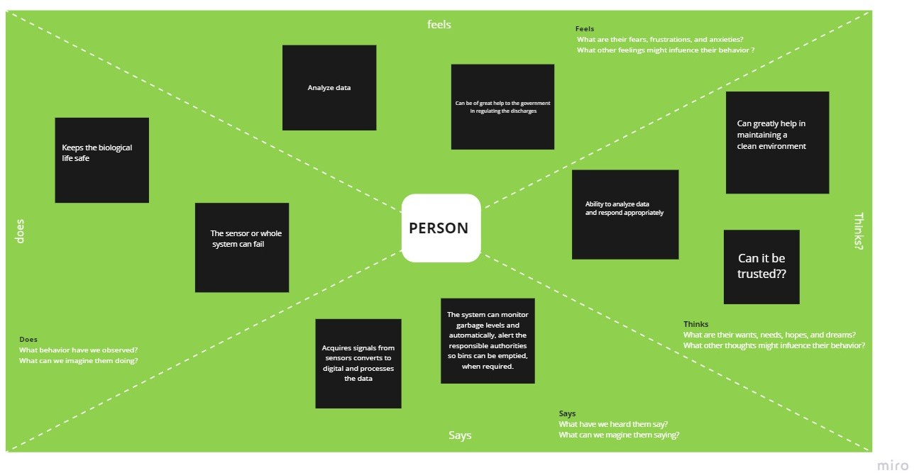

**3.2 Ideation and brainstorming:**

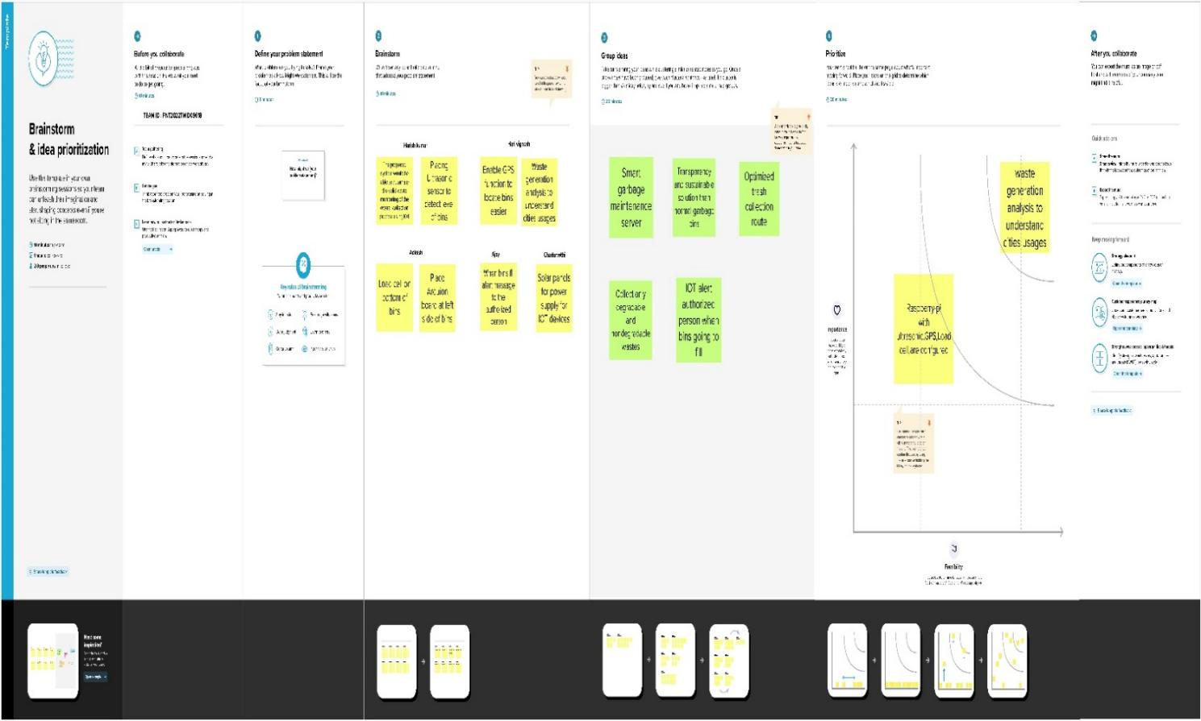

**EXPLANATION:**

The proposed system would be able to automate the solid waste monitoring of the overall collection process using IOT and placing ultrasonic sensor to detect level of bins and also enabling the GPS

function to locate bins easier. Waste generation analysis to understand cities usages.

when bins fill alert message to the authorized person. Solar panels for power supply for IOT devices.

The ideas related to project are the smart garbage maintenance server, transparency and sustainable solutions than normal garbage bins, optimized trash collection route. IOT alert authorized person when bins going to fill.

|  |  |  |
| --- | --- | --- |
| **SI No.** | **Parameter** | **Description** |
| 1. | Problem Statement (Problem to be solved) | Detecting the level of garbage and informing the garbage collectors through a proper communication channel about the garbage level and alerts them to collect it at a  specified time efficiently. |
| 2. | Idea / Solution description | By using fill level sensors we can detect the garbage level. Improving the communication channel using proper technology like WiMAX. Using GPS for tracking the location of bin and sorting out the short routes.  Using cloud service for the storage purpose. |
| 3. | Novelty / Uniqueness | By using IoT, GPS and GSM like technologies which if properly used in the establishment of this project helps to detect the garbage level and intimating about it to the authority and initiating them to collect the garbage on  time. |
| 4. | Social Impact / Customer Satisfaction | It keeps our surroundings clean and green and free from bad odour of wastes, emphasizes on healthy environment.  Reduces air pollution |
| 5. | Business Model (Revenue Model) | Smart waste management system is an innovative and effective step to analyze the production of waste annually and it helps to find the ways to reduce the factors which  increases the waste produced. |
| 6. | Scalability of the Solution | Smart waste management can attain its scalability by still more advancement in IoT and using many sensors to detect its accurate level accurately. Its implementation can be enhanced by using 5G type of technology for faster communication. AI recycling robots can be used in the nearer future. |

**3.3 Problem solution fit:**

**Step 1:**

**Problem solving cards**

**Step 2:**

**Framing statements**

**Step 3:**

**Ideas**

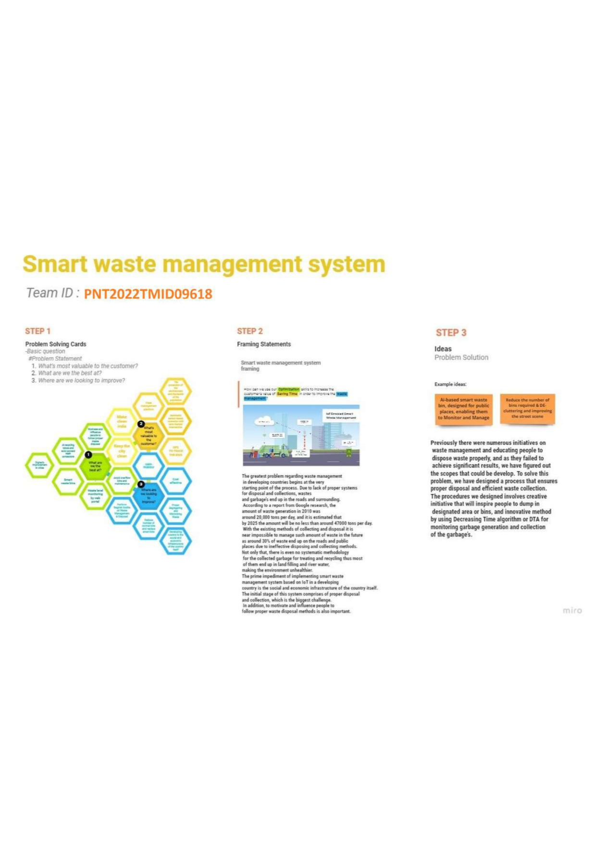

The greatest problem regarding waste management in developing countries begins at the very starting point . The prime impediment of implementing smart waste management system based on IOT in developing country’s social and economic infrastructure of the country.

# 4 .REQUIREMENT ANALYSIS

## 4.1 Functional requirement

|  |  |  |
| --- | --- | --- |
| **FR No.** | **Functional Requirement (Epic)** | **Sub Requirement (Story / Sub-Task)** |
| FR-1 | Detailed bin inventory. | The map shows all monitored bins and stands, and Street View from Google can be used to visit them at any time. Bins are shown as green, orange or red circles. The Dashboard shows bin details, such as waste type and  last measurement. You can see bin details in the Dashboard – capacity, waste type, last measurement, GPS location and collection schedule or pick recognition. |
| FR-2 | Real time bin monitoring. | Aside from displaying real-time data on fill-levels of bins monitored by smart sensors, the Dashboard also predicts when the bin will be full based on historical data, which is one of the most useful features.  Sensors recognize picks as well; so you can check when the bin was last collected.  With real-time data and predictions, you can eliminate the overflowing bins and stop collecting half-empty ones. |
| FR-3 | Expensive bins. | We help you identify bins that drive up your collection costs. The tool calculates a rating for each bin in terms of collection costs.  The tool considers the average distance depo-bin- discharge in the area. The tool assigns bin a rating  (1-10) and calculates distance from depo-bin discharge. |
| FR-4 | Adjust bin distribution. | Ensure the most optimal distribution of bins. Identify areas with either dense or sparse bin distribution.  Make sure all trash types are represented within a stand.  Based on the historical data, you can adjust bin capacity or location where necessary. |
| FR-5 | Eliminate inefficient picks. | Eliminate the collection of half-empty bins. The sensors recognize picks.  By using real-time data on fill-levels and pick  recognition, we can show you how full the bins you collect are. |
| FR-6 | Detailed bin inventory. | On the map, you can see every monitored bin and stand, and you can use Google Street View at any time to visit them. On the map, bins or stands appear as green, orange, or red circles. The Dashboard displays information about each bin,  including its capacity, trash kind, most recent measurement, GPS position, and pick-up schedule. |

**4.2 Non-Functional requirements:**

|  |  |  |
| --- | --- | --- |
| **FR No.** | **Non-Functional Requirement** | **Description** |
| NFR-1 | **Usability** | Usability is a unique and significant perspective to examine user needs, which may further enhance the design quality, according to IoT devices. Analysing how well people interact with a product may help designers better understand customers' prospective demands for waste management, behaviour, and experience in the design process when user experience is at the Centre. |
| NFR-2 | **Security** | Utilize recyclable bottles. Utilize reusable shopping bags. Spend responsibly and recycle Eat and drink in limited-use containers. |
| NFR-3 | **Reliability** | Creating improved working conditions for garbage collectors and drivers is another aspect of smart waste management. Waste collectors will use their time more effectively by attending to bins that require service rather than travelling the same collection routes and servicing empty bins. |
| NFR-4 | **Performance** | The Smart Sensors assess the fill levels in bins (along with other data) numerous times each day using ultrasonic technology. The sensors feed data to Senone’s Smart Waste Management Software System, a robust cloud-based platform with datadriven daily operations and a waste management app, using a variety of IoT networks (NB-IoT, GPRS). As a consequence, customers receive data-driven decision-making services, and garbage collection routes, frequency, and truck loads are optimized, resulting in at least a 30% decrease in route length. |
| NFR-5 | **Availability** | By creating and implementing robust hardware and gorgeous software, we enable cities, companies, and nations to manage garbage more intelligently. |

# 5 . PROJECT DESIGN:

## 5.1 Data Flow Diagrams:

A Data Flow Diagram (DFD) is a traditional visual representation of the information flows within a system. A neat and clear DFD can depict the right amount of the system requirement graphically. It shows how data enters and leaves the system, what changes the information, and where data is stored A smart waste management platform uses analytics to translate the data gather in your **bins into actionable insights to help you improve your waste services.** You can receive data on metric such as:

* The first test conducted is the situation where the garbage bin is empty or its garbage level is very low
* Then, the bin is filled with more garbage until its level has surpassed the first threshold **value, which is set to 80% then the first warning SMS is being sent, as depicted**
* The first notification SMS sent by the system, once the waste reaches the level of 85% full
* The second notification SMS sent by the system, indicating that bin is at least 95% full and **the garbage needs to be collected immediately**
* Locations prone to overflow
* The number of bins needed to avoid overflowing waste
* The number of collection services that could be saved
* The amount of fuel that could be saved
* The driving distance that could be saved

**Data flow diagram:**

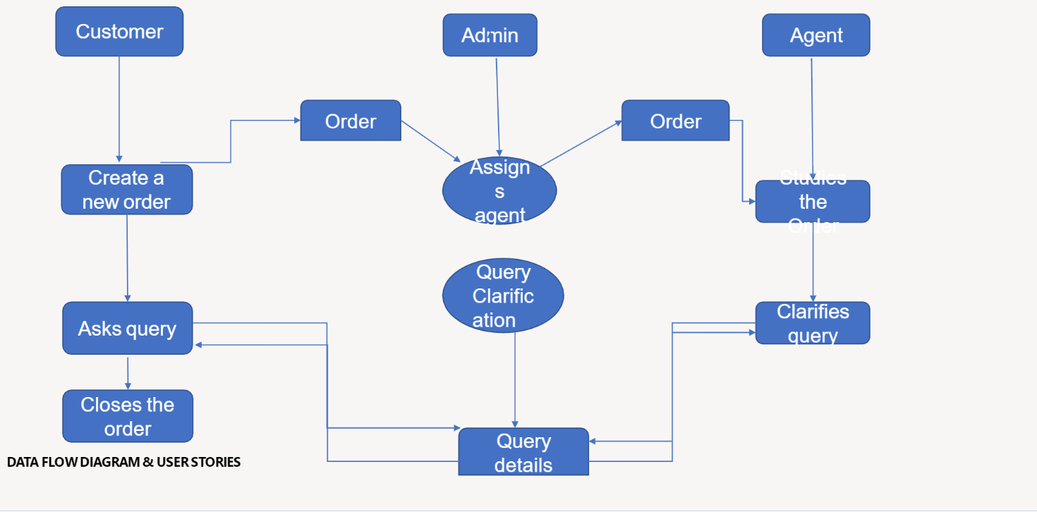

**5.2 Solution & Technical Architecture:**

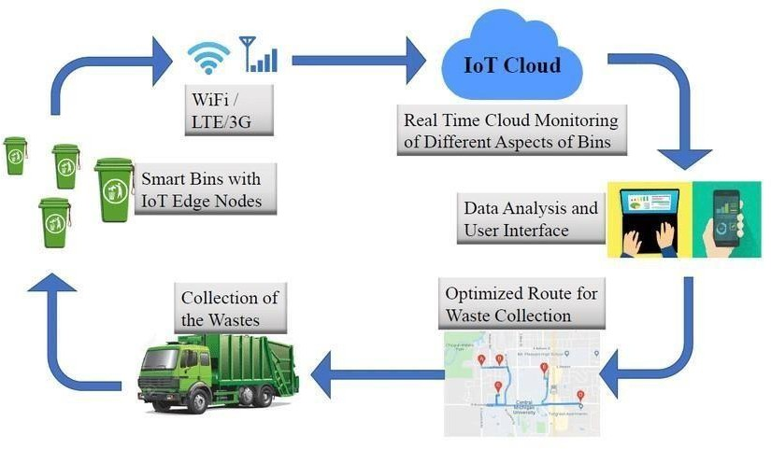

**5.3 User stories:**

|  |  |  |  |  |  |  |
| --- | --- | --- | --- | --- | --- | --- |
| Admin(who manages  server) | Web server login | USN-1 | As a admin, I can able to track the truck driver name,  id, contact number, location, and also the location of the dustbin. | I can Manage and direct workers through web server | High | Sprint-1 |

|  |  |  |  |  |  |  |
| --- | --- | --- | --- | --- | --- | --- |
| Co-Admin | Login | USN-2 | As a co-admin I’ll monitor the workers, whether the work has been done properly, checking the availability of workers and also monitor the waste collected by the truck driver within the  scheduled time | I can monitor the  garbage bin activity | High | Sprint-1 |
| Customer (Web user) | User | USN-3 | As a user , I can able to raise queries to higher authorities about the maintenance and disposal of waste | I can raise queries | Medium | Sprint-2 |
| Customer Care Executive | Worker | USN-4 | As a customer care executive I will try to rectify the queries from customers by contacting coadmin. In case of emergency situation query can be reported to Admin. | I can attend calls and respond  people and solve their problems | High | Sprint-1 |

|  |  |  |  |  |  |  |
| --- | --- | --- | --- | --- | --- | --- |
| Truck driver | Worker | USN-5 | The truck driver is a worker who has been assigned to collect the garbage and he have to report  to admin about when and where  and also the  timings , the garbage has been picked up according the  daily schedule. | I will do the work properly and report the data at the scheduled time | High | Sprint1 |

# 6 . PROJECT PLANNING & SCHEDULING:

## 6.1 Sprint Planning & Estimation:

|  |  |  |
| --- | --- | --- |
| PHASE | TITLE | DESCRIPTION |
| Ideation Phase | Literature Survey & | Literature survey on the |
| Information Gathering | selected project & gathering information by referring the, technical papers, research publications etc. |
| Prepare Empathy Map | Prepare Empathy Map Canvas to capture the user Pains & Gains, Prepare list of problem statements |

|  |  |  |
| --- | --- | --- |
|  | Ideation | List the by organizing the brainstorming session and prioritize the top 3 ideas based on the feasibility & importance. |
| Phase-1 | Proposed Solution | Prepare the proposed solution document, which includes the novelty, feasibility of idea, business model, social impact, scalability of solution, etc. |
| Problem Solution Fit | Prepare problem - solution fit document. |
| Solution Architecture | Prepare solution architecture document. |
| Phase-2 | Customer Journey | Prepare the customer journey maps to understand the user interactions & experiences with the application (entry to exit). |
| Functional Requirement | Prepare the functional and Nonfunctional requirement document. |
|  |  |
|  | Data Flow Diagrams | Draw the data flow diagrams and submit for review. |
| Technology Architecture | Prepare the technology architecture diagram. |
| Project planning phase | Prepare Milestone & Activity List | Prepare the milestones & activity list of the project. |

|  |  |  |
| --- | --- | --- |
| Project development phase | Project Development - Delivery of Sprint-1, 2, 3 & 4 | Develop & submit the developed code by testing it. |

**6.2 Sprint Delivery Schedule:**

|  |  |  |  |  |  |
| --- | --- | --- | --- | --- | --- |
| Sprint | Functional Requirement(Epic) | Task | Story Point | Priority | Team Member |
| 1 | Sprint – Requirement | As a team lead, I can enrolled for the project by entering my email, passwordand within that I can enter my team members name and their email. | 2 | High | HariVignesh |
| 2 | Sprint - Login | As a team member, i can login to the IBM portal by entering email & password | 1 | Medium | aakash |
| 3 | Sprint - Login | As a team member, i can login to the IBM portal by entering email & password | 1 | Medium | Harish KumarG |
| 4 | Sprint - Login | As a team member, i can login to the IBM portal by entering email & password | 1 | Medium | Ajay |

# 6.3 Reports from JIRA:

### Burnout Chart:

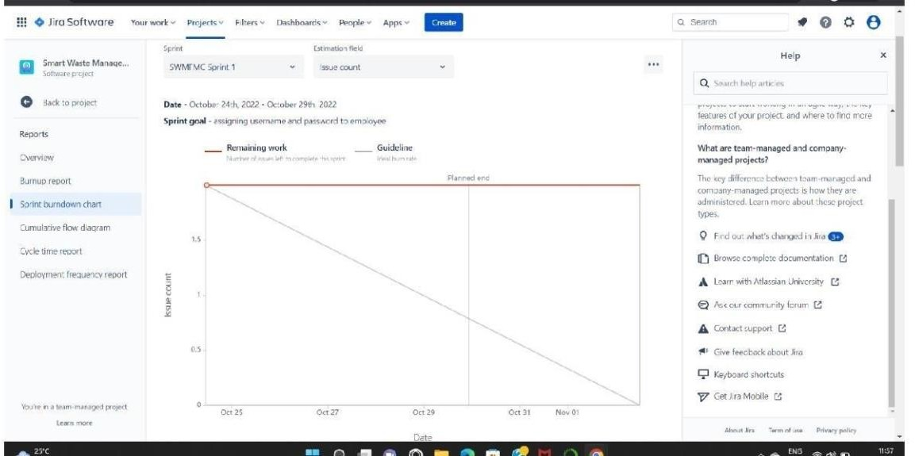

**Roadmap:**

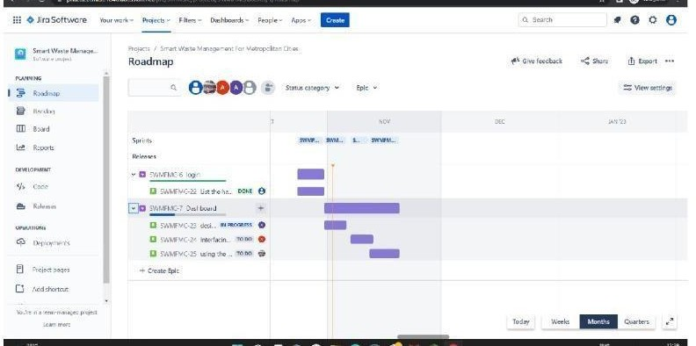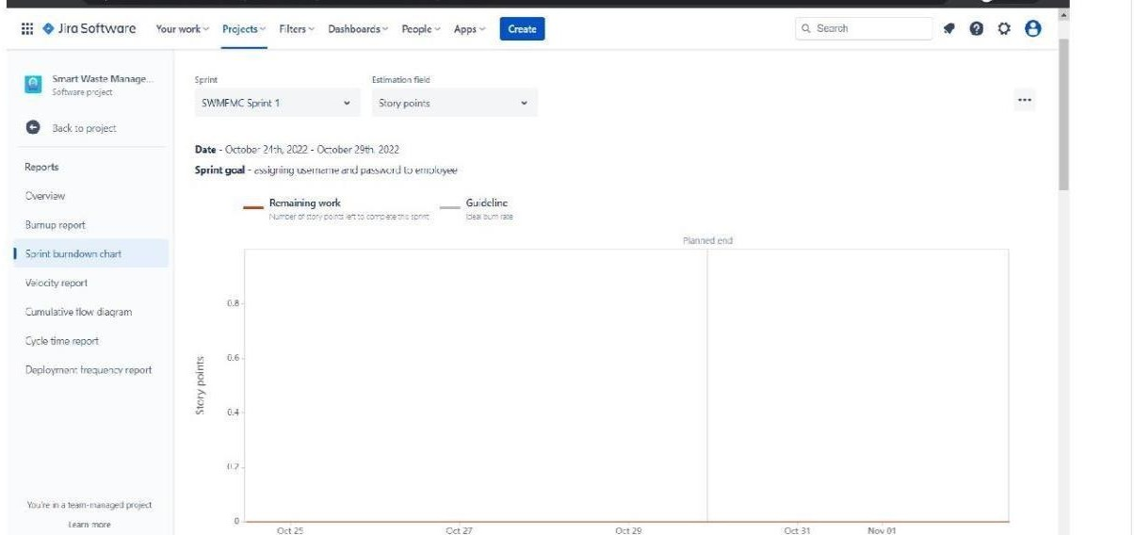

# 7.CODING & SOLUTIONING:

7.1 Feature 1- LOCATION TRACKER

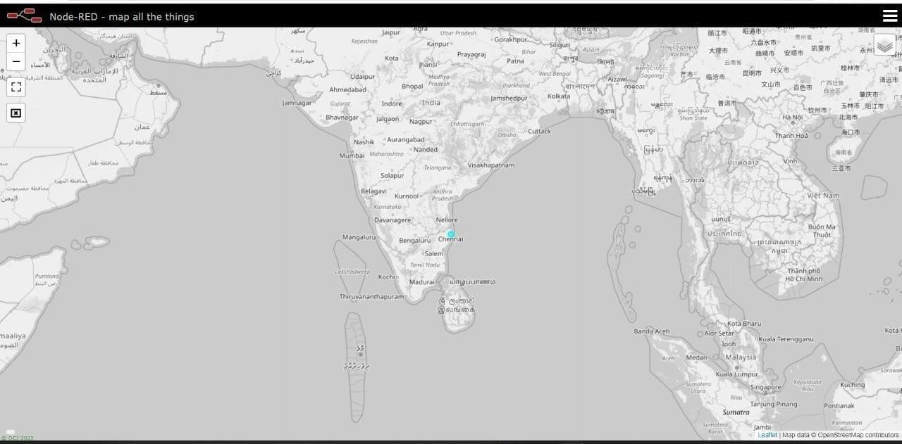

7.2 Feature 2 Live update on collecting data

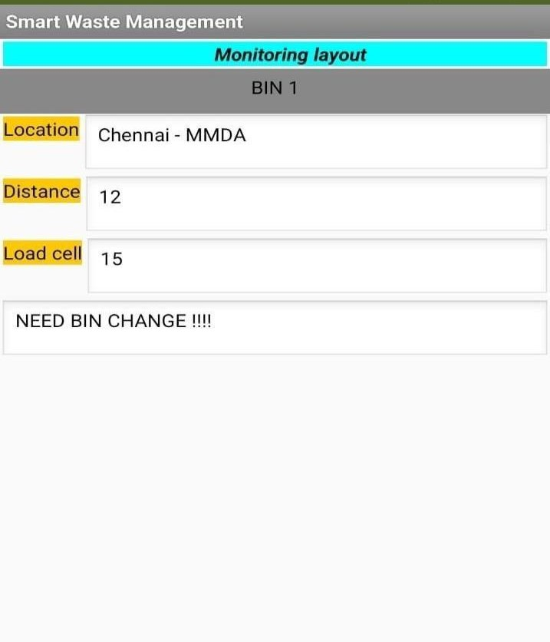

**8 . Testing**

8.1 Testcase:

|  |  |  |  |  |
| --- | --- | --- | --- | --- |
| **Test Case ID** | **Feature Type** | **Status** | **Comments** | **Executed By** |
| Login page TC 001 | Functional | Pass | Successful | Harivignesh |
| Login page TC 002 | Functional | Pass | Successful | Harishkumar |
| Login page TC 003 | Functional | Pass | Successful | Aakash |
| Login page TC 004 | Functional | Pass | Successful | Ajay |
| Login page TC 005 | Functional | Pass | Successful | Chadurvethi |

8.2 User accepting testing :

1. Purpose of document:

The purpose of this document is to briefly explain the test coverage and open issues of the [ProductName] project at the time of the release to User Acceptance Testing (UAT).

1. Defect analysis :

This report shows the number of resolved or closed bugs at each severity level, and how they were resolved

|  |  |  |  |  |  |
| --- | --- | --- | --- | --- | --- |
| **Resolution** | **Severity 1** | **Severity 2** | **Severity 3** | **Severity 4** | **Subtotal** |
| By Design | 10 | 4 | 2 | 3 | 20 |
| Duplicate | 1 | 0 | 3 | 0 | 4 |
| External | 2 | 3 | 0 | 1 | 6 |
| Fixed | 11 | 2 | 4 | 20 | 37 |

|  |  |  |  |  |  |
| --- | --- | --- | --- | --- | --- |
| Not Reproduced | 0 | 0 | 1 | 0 | 1 |
| Skipped | 0 | 0 | 1 | 1 | 2 |
| Won't Fix | 0 | 5 | 2 | 1 | 8 |
| Totals | 24 | 14 | 13 | 26 | 7 |

### 1. Test Case Analysis:

This report shows the number of test cases that have passed, failed, and untested

|  |  |  |  |  |
| --- | --- | --- | --- | --- |
| **Section** | **Total Cases** | **Not Tested** | **Fail** | **Pas s** |
| Print Engine | 7 | 0 | 0 | 7 |

|  |  |  |  |  |
| --- | --- | --- | --- | --- |
| Client Application | 51 | 0 | 0 | 51 |
| Security | 2 | 0 | 0 | 2 |
| Outsource Shipping | 3 | 0 | 0 | 3 |
| Exception Reporting | 9 | 0 | 0 | 9 |
| Final Report Output | 4 | 0 | 0 | 4 |
| Version Control | 2 | 0 | 0 | 2 |

**9.Results**

9.1 Performance metrics

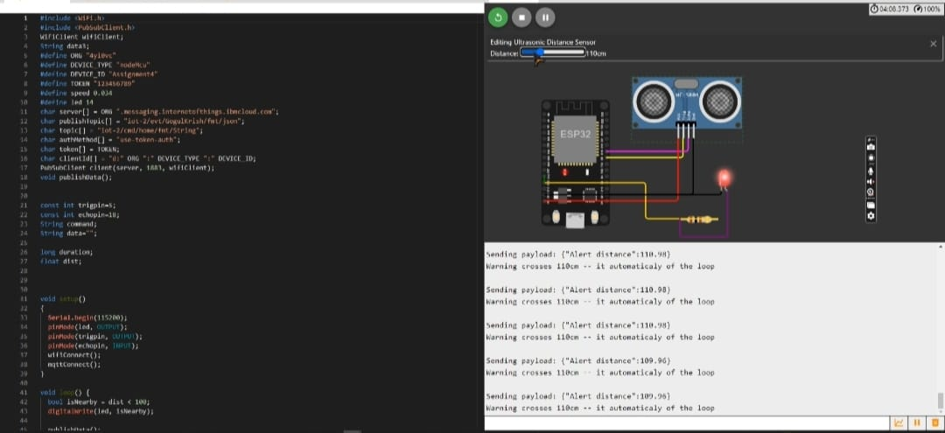

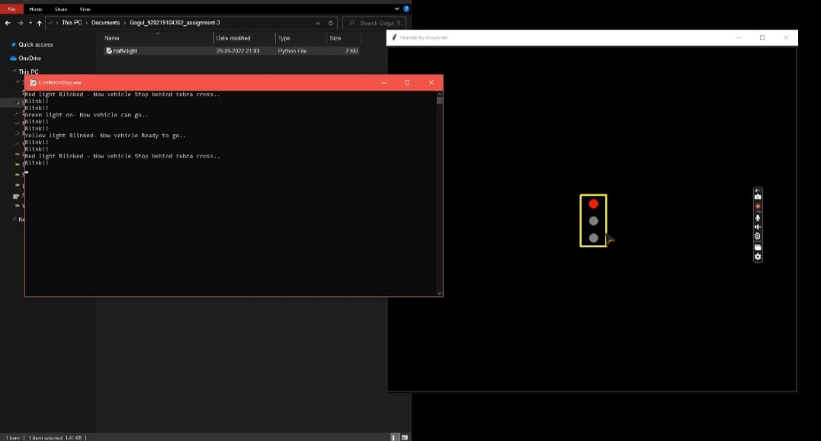

N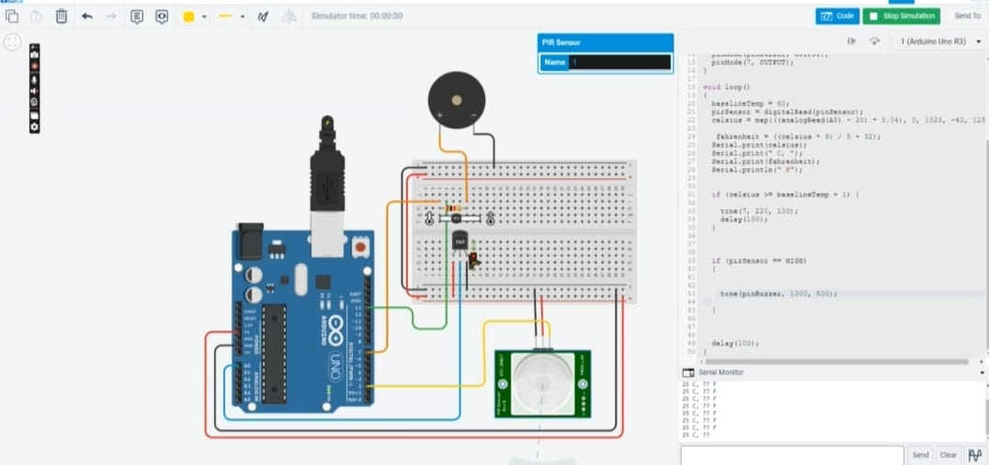

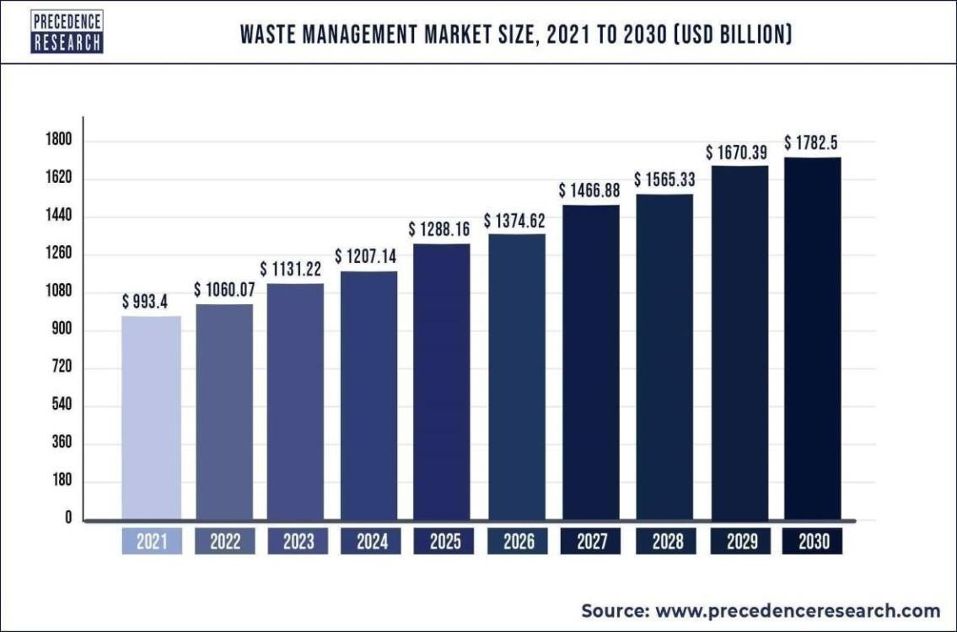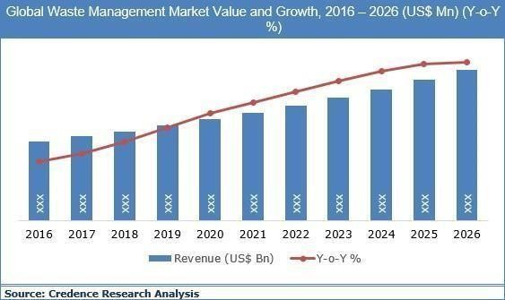

1. **Advantages and Disadvantage:**

**Advantages**

* No Missed Pickups
* Reduced Overflows
* Waste Generation Analysis •
* CO2 Emission Reduction

## Disadvantages:

* System requires a greater number of waste bins for separate waste collection as per population in the city.
* This results into high initial cost due to expensive smart dustbins compare to other methods. Sensor nodes used in the dustbins have limited memory size.

# CONCLUSION:

A Smart Waste Management system that is more effective than the one in use now is achievable by using sensors to monitor the filling of bins. Our conception of a "smart waste management system" focuses on monitoring waste management, offering intelligent technology for waste systems, eliminating human intervention, minimizing human time and effort, and producing a healthy and trash-free environment. The suggested approach can be implemented in smart cities where residents have busy schedules that provide little time for garbage management. If desired, the bins might be put into place in a metropolis where a sizable container would be able to hold enough solid trash for a single unit. The price might be high.

# 12. FUTURE SCOPE:

There are several future works and improvements for the proposed system, including the following:

1. Change the system of user authentication and atomic lock of bins, which would aid in protecting the bin from damage or theft.
2. The concept of green points would encourage the involvement of residents or end users, making the idea successful and aiding in the achievement of collaborative waste management efforts, thus fulfilling the idea of Swachh Bharath.
3. Having case study or data analytics on the type and times waste is collected on different days or seasons, making bin filling predictable and removing the reliance on electronic components, and fixing the coordinates.
4. Improving the Server's and Android's graphical interfaces

**13 . Appendix**

**Source code Github Link :** <https://github.com/IBM-EPBL/IBM-Project-26207-1660020965>

**Project Demo Link : https://youtu.be/k35fvEE76sE**